COTO DE HAYAS CRIANZA
Grape Varieties  Grenache and Tempranillo.  Soil  Red, stony soil.  Vinification  Traditional wine making at 28°C in stainless steel deposits under controlled temperature. Maceration for 15 days is carried out, after which the malolactic fermentation is carried out for each variety separately. The wine is then blended and aged in French and American oak barrels for 6-9 months. | 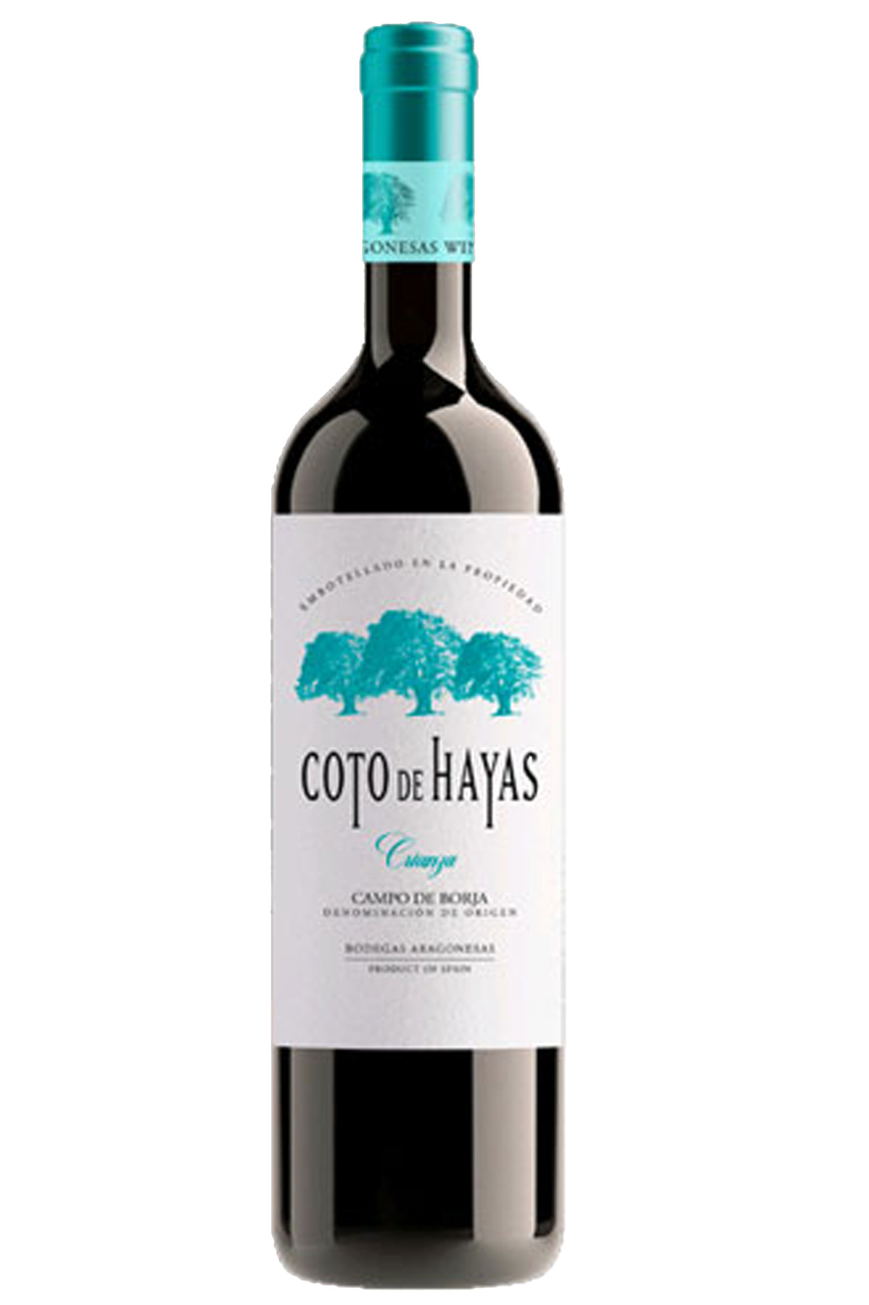
Tasting notes.
Intense red colour with violet tones; clean and bright. The nose is intense and complex with spice and ripe berry aromas. On the palate this wine is smooth and harmonious, with good acidity and integrated tannins. Plenty of black and red berries, spices, cocoa, and tobacco, with a slight peppery finish.

